WEEK-1 Algorithms_Data_Structures

**Exercise 2: E-commerce Platform Search Function**

**Understanding regarding the approach:**

The product search demonstrates how linear and binary search algorithms work in different scenarios. Linear search scans each product one by one, while binary search quickly narrows down the result using a sorted list. Choosing between them depends on the dataset size and whether it's sorted or not.

**CODE:**

**public class Product {  
 private int productId;  
 private String productName;  
 private String category;  
  
 public Product(int productId, String productName, String category) {  
 this.productId = productId;  
 this.productName = productName;  
 this.category = category;  
 }  
  
 public int getProductId() {  
 return productId;  
 }  
  
 public void setProductId(int productId) {  
 this.productId = productId;  
 }  
  
 public String getProductName() {  
 return productName;  
 }  
  
 public void setProductName(String productName) {  
 this.productName = productName;  
 }  
  
 public String getCategory() {  
 return category;  
 }  
  
 public void setCategory(String category) {  
 this.category = category;  
 }  
  
 @Override  
 public String toString() {  
 return "Product{" +  
 "productId=" + productId +  
 ", productName='" + productName + '\'' +  
 ", category='" + category + '\'' +  
 '}';  
 }  
}**

**import java.util.Arrays;  
import java.util.Comparator;  
  
public class SearchUtil {  
  
 public static Product linearSearch(Product[] products, String name) {  
 for (Product product : products) {  
 if (product.getProductName().equalsIgnoreCase(name)) {  
 return product;  
 }  
 }  
 return null;  
 }  
  
 public static Product binarySearch(Product[] products, String name) {  
 int low = 0, high = products.length - 1;  
 while (low <= high) {  
 int mid = (low + high) / 2;  
 int comparison = products[mid].getProductName().compareToIgnoreCase(name);  
 if (comparison == 0) return products[mid];  
 else if (comparison < 0) low = mid + 1;  
 else high = mid - 1;  
 }  
 return null;  
 }  
  
 public static void sortByName(Product[] products) {  
 Arrays.*sort*(products, Comparator.*comparing*(Product::getProductName));  
 }  
}**

**public class Main {  
 public static void main(String[] args) {  
 Product[] products = new Product[]{  
 new Product(1, "Laptop", "Electronics"),  
 new Product(2, "Shoes", "Fashion"),  
 new Product(3, "Book", "Education"),  
 new Product(4, "Mobile", "Electronics"),  
 new Product(5, "Watch", "Accessories")  
 };  
  
 String targetName = "Mobile";  
  
 System.*out*.println("By using Linear search:");  
 Product foundLinear = SearchUtil.*linearSearch*(products, targetName);  
 System.*out*.println(foundLinear != null ? foundLinear : "Could Not Find Product");  
  
  
 SearchUtil.*sortByName*(products);  
 System.*out*.println();  
 System.*out*.println("By using Binary search:");  
 Product foundBinary = SearchUtil.*binarySearch*(products, targetName);  
 System.*out*.println(foundBinary != null ? foundBinary : "Could Not Find Product");  
 }  
}**

OUTPUT:

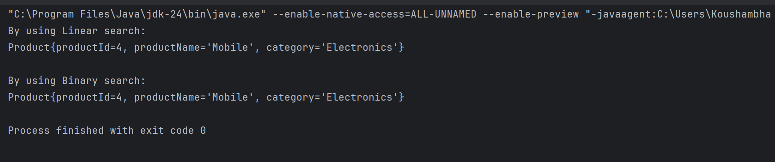

**Analysis:**

1. Linear Search

* Time Complexity:
  + Best Case: O(1) — if the element is at the beginning.
  + Average Case: O(n) — requires scanning half the list on average.
  + Worst Case: O(n) — if the element is at the end or not present.
* Advantages:
  + Simple to implement.
  + Works on unsorted data.
  + Suitable for small datasets.
* Disadvantages:
  + Inefficient for large datasets.
  + Requires scanning every element in the worst case.
* Use Case:
  + Use when the data is frequently changing or not sorted.

2. Binary Search

* Time Complexity:
  + Best Case: O(1) — if the middle element matches.
  + Average Case: O(log n).
  + Worst Case: O(log n).
* Advantages:
  + Much faster than linear search for large datasets.
  + Reduces time complexity significantly due to divide-and-conquer.
* Disadvantages:
  + Requires data to be sorted.
  + If data changes frequently, maintaining sort order adds overhead.
* Use Case:
  + Ideal for large, static datasets where the data doesn't change often.
  + Best when fast search speed is critical and the list is sorted.

**Exercise 7: Financial Forecasting**

**Understanding of Recursion and Iterative Approach:**

Recursion:  
Recursion solves problems by breaking them down into smaller subproblems, where a method calls itself until it reaches a base case. It is elegant but can consume more memory due to stack calls.

Iteration:  
Iteration uses loops to repeat operations and is generally more memory-efficient. It is preferred for performance-critical tasks due to lower overhead and better control flow.

**CODE:**

**public class FinancialForecastRecursive {  
  
 public static double calculateFutureValue(double presentValue, double rate, int periods) {  
 if (periods == 0) {  
 return presentValue;  
 }  
  
 return (1 + rate) * *calculateFutureValue*(presentValue, rate, periods - 1);  
 }  
  
 public static void main(String[] args) {  
 double presentValue = 1000.0;  
 double rate = 0.05;  
 int periods = 5;  
  
 double futureValue = *calculateFutureValue*(presentValue, rate, periods);  
 System.*out*.println("By Recursive approach - Future value is after " + periods + " years:" + String.*format*("%.2f", futureValue));  
 }  
}**

OUTPUT (Recursive Approach):

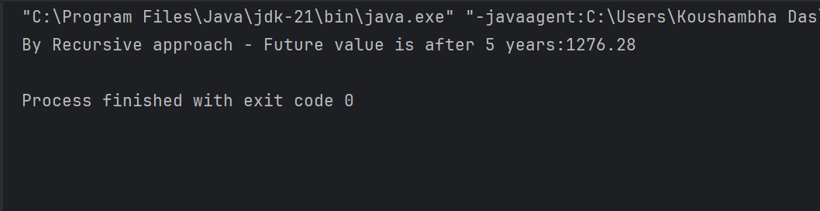

**CODE:**

**public class FinancialForecastOptimized {  
 public static double calculateFutureValue(double presentValue, double rate, int periods) {  
 double result = presentValue;  
 for (int i = 0; i < periods; i++) {  
 result *= (1 + rate);  
 }  
 return result;  
 }  
  
 public static void main(String[] args) {  
 double presentValue = 1000.0;  
 double rate = 0.05;  
 int periods = 5;  
  
 double futureValue = *calculateFutureValue*(presentValue, rate, periods);  
 System.*out*.println("By Iterative approach - The Future Value after " + periods + " years: " + String.*format*("%.2f", futureValue));  
 }  
}**

OUTPUT (Iterative/Optimized Approach):

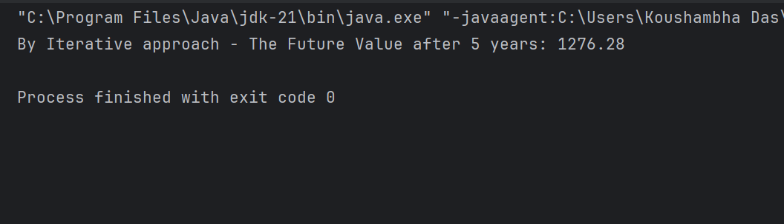

**Analysis:**

1. **Purpose**: Calculates future value using compound interest with an iterative method.
2. **Inputs**:

* presentValue = 1000.0
* rate = 0.05 (5%)
* periods = 5 years

1. **Logic**: Uses a for loop to multiply presentValue by (1 + rate) for each period.
2. **Time Complexity**: O(n) – loop runs n times.
3. **Space Complexity**: O(1) – constant space used.
4. **Output**: Prints the future value rounded to 2 decimal places.
5. **Efficiency**: More efficient than recursion; no stack overhead.
6. **Limitation**: Inputs are hardcoded and not dynamic.